PE Funding

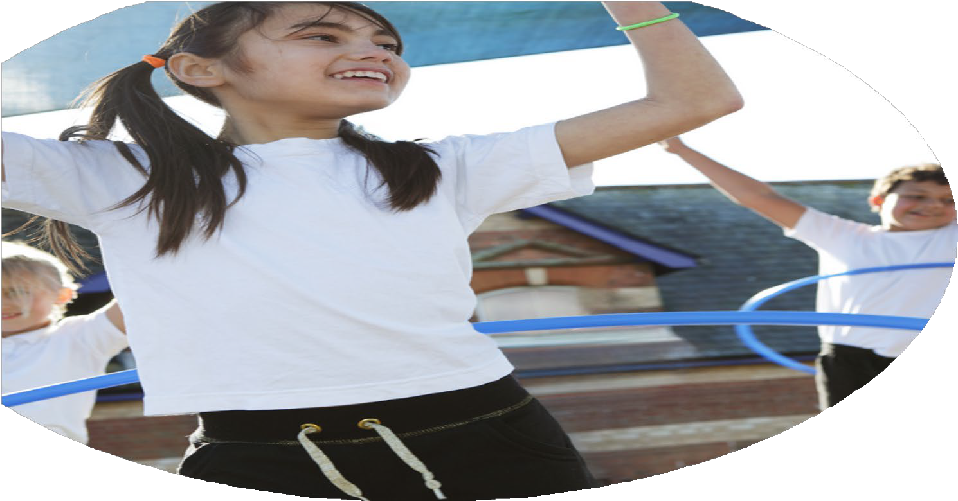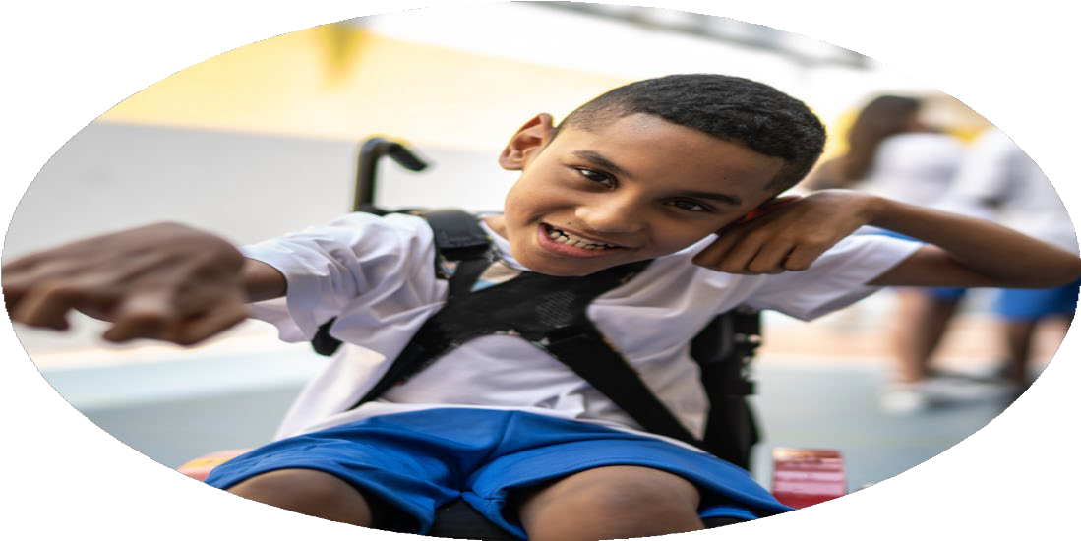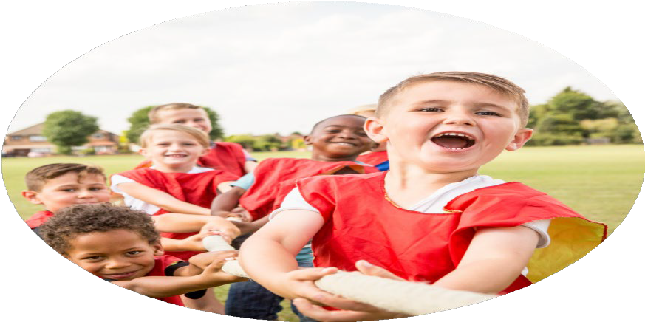

Evaluation Form

**Commissioned by**

**Created by**

Images courtesy of Youth Sport Trust

**PE Funding Evaluation Form**

 It is intended that this template should be used as preparation for the completion of the statutory digital reporting tool being introduced this academic year. You can upload data (including swimming) from this template onto this platform once it becomes accessible.

 Before you decide how you are going to use the funding for this academic year you should reflect and evaluate the impact of your use of the funding in 2023/24.

 All spending of the funding must conform with the terms outlined in the Conditions of Grant document.  The template is a working document that you can amend/update during the year.

 Based on your evaluation of last year’s funding you should decide what you intend to do this academic year, how you will do it, and what impact you expect it to have.

It is important that the funding is used effectively and based on your school’s needs.

 You must use the funding to make additional and sustainable improvements to the PE and sport in your school.  You must develop and add to the PESSPA activities that your school already offers.

*Summative digital reporting from June 2025 will continue to include swimming and water safety information therefore funding can be used to provide top-up lessons where necessary to ensure pupils meet national curriculum swimming requirements.*

**We recommend that you start by reflecting on the impact of current provision and reviewing your previous spend**

|  |  |  |  |
| --- | --- | --- | --- |
| What went well? | How do you know? | What didn’t go well? | How do you know? |
| *\* Increase the hours of physical activity and range of children’s sport experiences.*  *\* To provide adaptive teaching for AGT and SEND needs throughout the curriculum.* | Teachers have been looking at ways to make their lessons more active this year. We have embedded movement breaks, active assemblies, sensory circuits areas and invested in more equipment for the children to use at breaktimes  * Our new sports coordinator has provided extra support for both our AGT and SEND children, where needed through our PE lessons.  * A new sensory circuits area has been developed to support children with SEND barriers  * BEAM programme delivered to Reception by our sports coordinator to improve gross motor skills and coordination  * Funding used to upskill our sports coordinator (Healthy Movers, PE Conference, Dance and Gymnastics)  * Teachers are using the Lancs PE app to support their judgements when assessing children during PE  * Our SEND children attended an inclusive football event at Morecambe Road School, which they thoroughly enjoyed.  * Wheelchair Basketball with Shaun Gash | Although we have more provision outside for the children, we didn’t feel like there was a high level of intensity in some of the zones. | In 2024/25, we will look at the quality of provision and how we can get more children moving with a higher level of intensity. |

|  |  |
| --- | --- |
| What are your plans for 2024/25? | How are you going to action and achieve these plans? |
| Intent | Implementation |
| - To increase the confidence, knowledge and skills of all staff in teaching PE and sport.  - Engagement of all pupils in regular physical activity  - The profile of PE and sport is raised across the school as a tool for whole school improvement | * CPD courses through our SSN package to uplevel skills. * CPD delivered by specialist coaches, working with teachers during PE lessons to learn more about high quality PE in the area they have less confidence in. * CPD for welfare staff to help run lunchtime sessions. * Observations, surveys and professional conversations with staff will help to understand areas of need and look at ways we can work together to address these needs. * Upgrade our SSN package to the Gold package to be able to assess the higher level of CPD and sporting opportunities for the children. * Continue to purchase and use the Lancs PE app to help teachers to plan, assess and provide our children with a high-quality sequence of learning. Ensures staff are confident at differentiating lessons to suit the needs of the children in their class. * Max Whitlock Gymnastics Bolt On to ensure gymnastics is taught with confidence and at a high level. Videos to help demonstrate good technique and skills. * Purchase more equipment to create active and engaging zones in the playground, which will encourage higher levels of intensity and physical activity. * Regular pupil surveys and Sports Council meetings to help plan our after-school clubs, targeting our least active pupils. * Run parent/child after school clubs to encourage our families to be more active outside school hours. * Continue to be a part of the Living Streets Walk to School Scheme. * To offer a broader range of sports and after school clubs generated by our pupil surveys * Run parent/child after school clubs to highlight the importance of being physically active * Continue to run active assemblies and celebrate sporting achievements out of school. * Louise, our sports coordinator, to run active games at break and lunchtime * Set up Sports Council, with hoodies for Sports Captain and pin badges for other children to raise profile of keeping active. * Purchase sports-themed books to get more children reading for pleasure. |

|  |  |
| --- | --- |
| What impact/intended impact/sustainability are you  expecting? | How will you know? What **evidence** do you have or  expect to have? |
| - To increase the confidence, knowledge and skills of all staff in teaching PE and sport.  We would be expecting the impact of CPD in their specific area of need would lead to more confidence to teach PE and we would expect to see an increase in knowledge and skills during observations. We will aim to sustain this by sharing good practice between staff and holding regular CPD sessions to increase confidence, knowledge and skills.  - Engagement of all pupils in regular physical activity  Through the planning and implementation of new playground equipment, we would be hoping to see more children engaging in more intense activity during playtimes and lunch times. This should have more of an impact on fitness levels, motor skills and behaviour for learning. We will monitor this through surveys and counting sedentary children before and after the purchase of equipment. We will purchase good quality equipment and use Y5/6 helpers to ensure equipment is looked after and put away properly. We will regularly assess any areas that are not having the impact required and make adjustments, based on the feedback from the children.  - Broader experience of a range of sports and activities offered to all pupils  Through pupil questionnaires, carried out by the Sports Council, we will find out which sports interest the children and offer these as extra-curricular clubs. We will also provide the children with a variety of clubs and sports that they may not have tried before, such as Curling and Korfball. We would be encouraging and expecting to see more children participating in unfamiliar sports and activities. | * Staff survey results * Evidence from observations to show that the CPD has had an impact on the confidence, knowledge and skills of the teacher. * Informal feedback after the CPD to assess the quality of the CPD and confidence of the teacher to put ideas into practice. * Pupil survey to assess engagement * Staff survey to assess impact on behaviour in class and during breaktimes * Head count of sedentary children before and after implementation of equipment * Tracking pupils through the registers * Pupil surveys |

|  |  |
| --- | --- |
| What **impact/sustainability** have you seen? | What **evidence** do you have? |
|  |  |