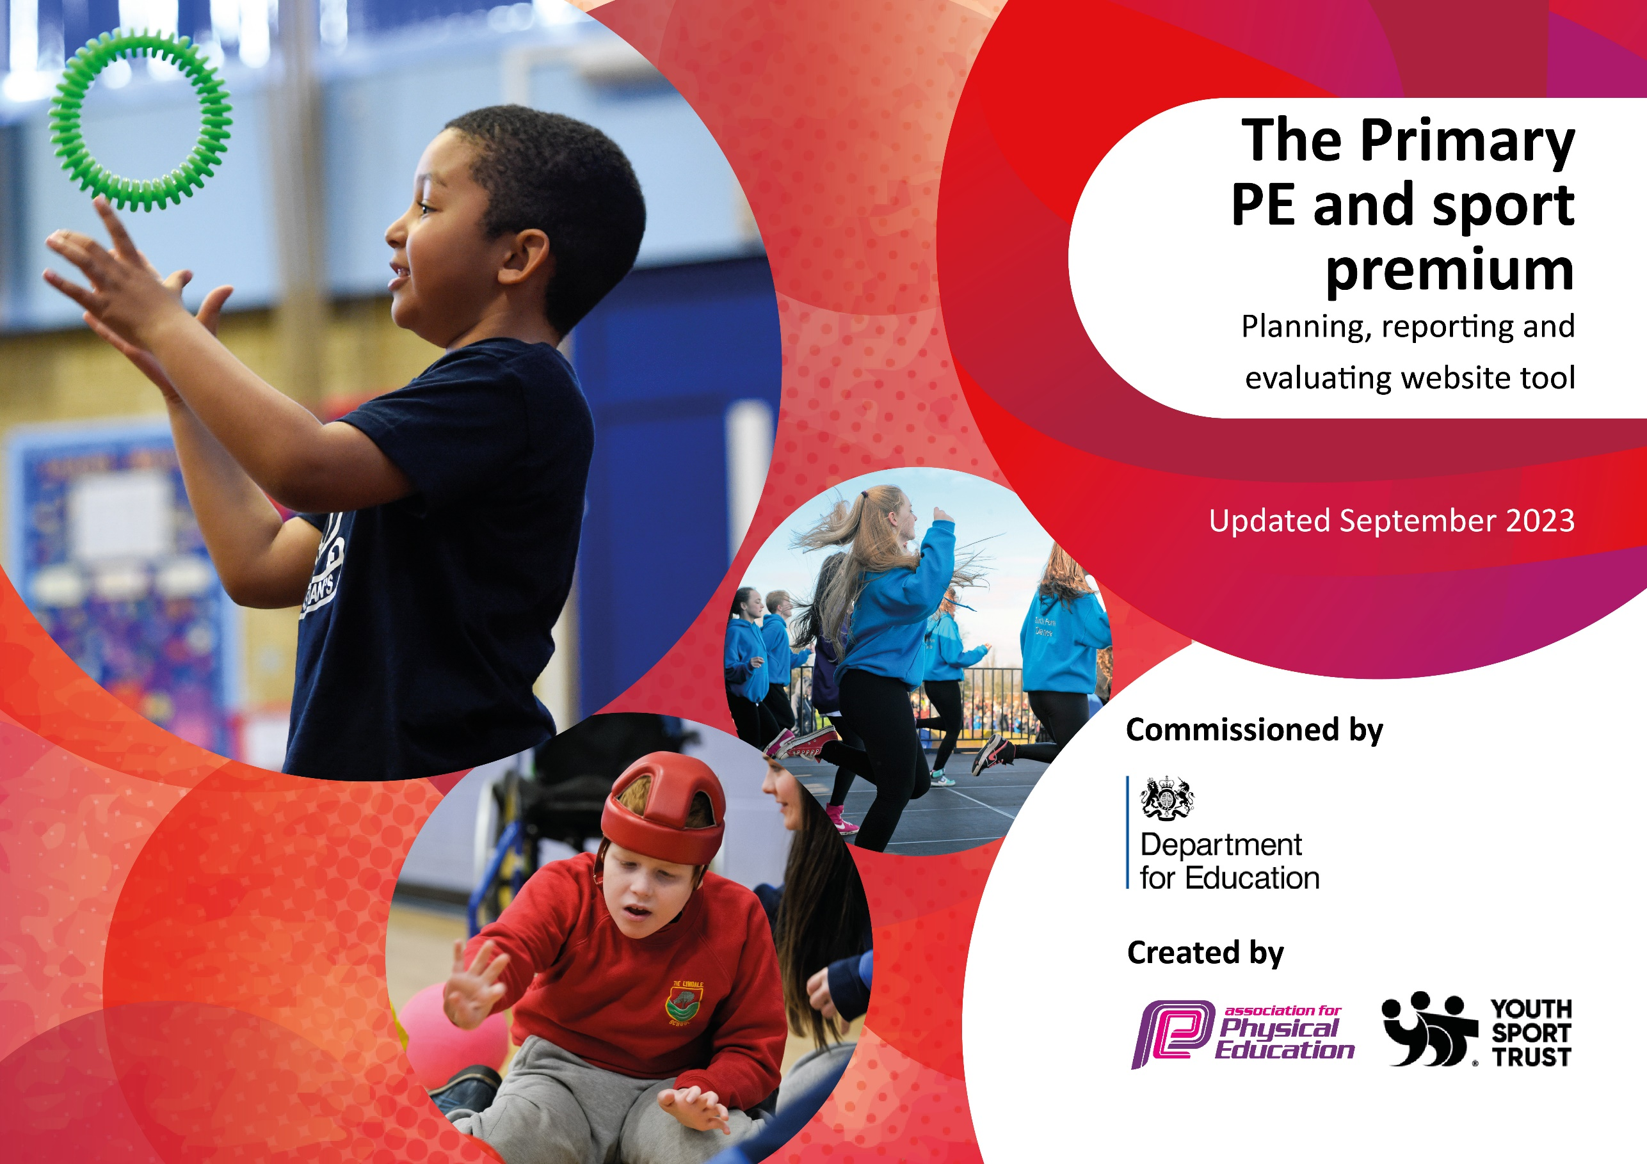

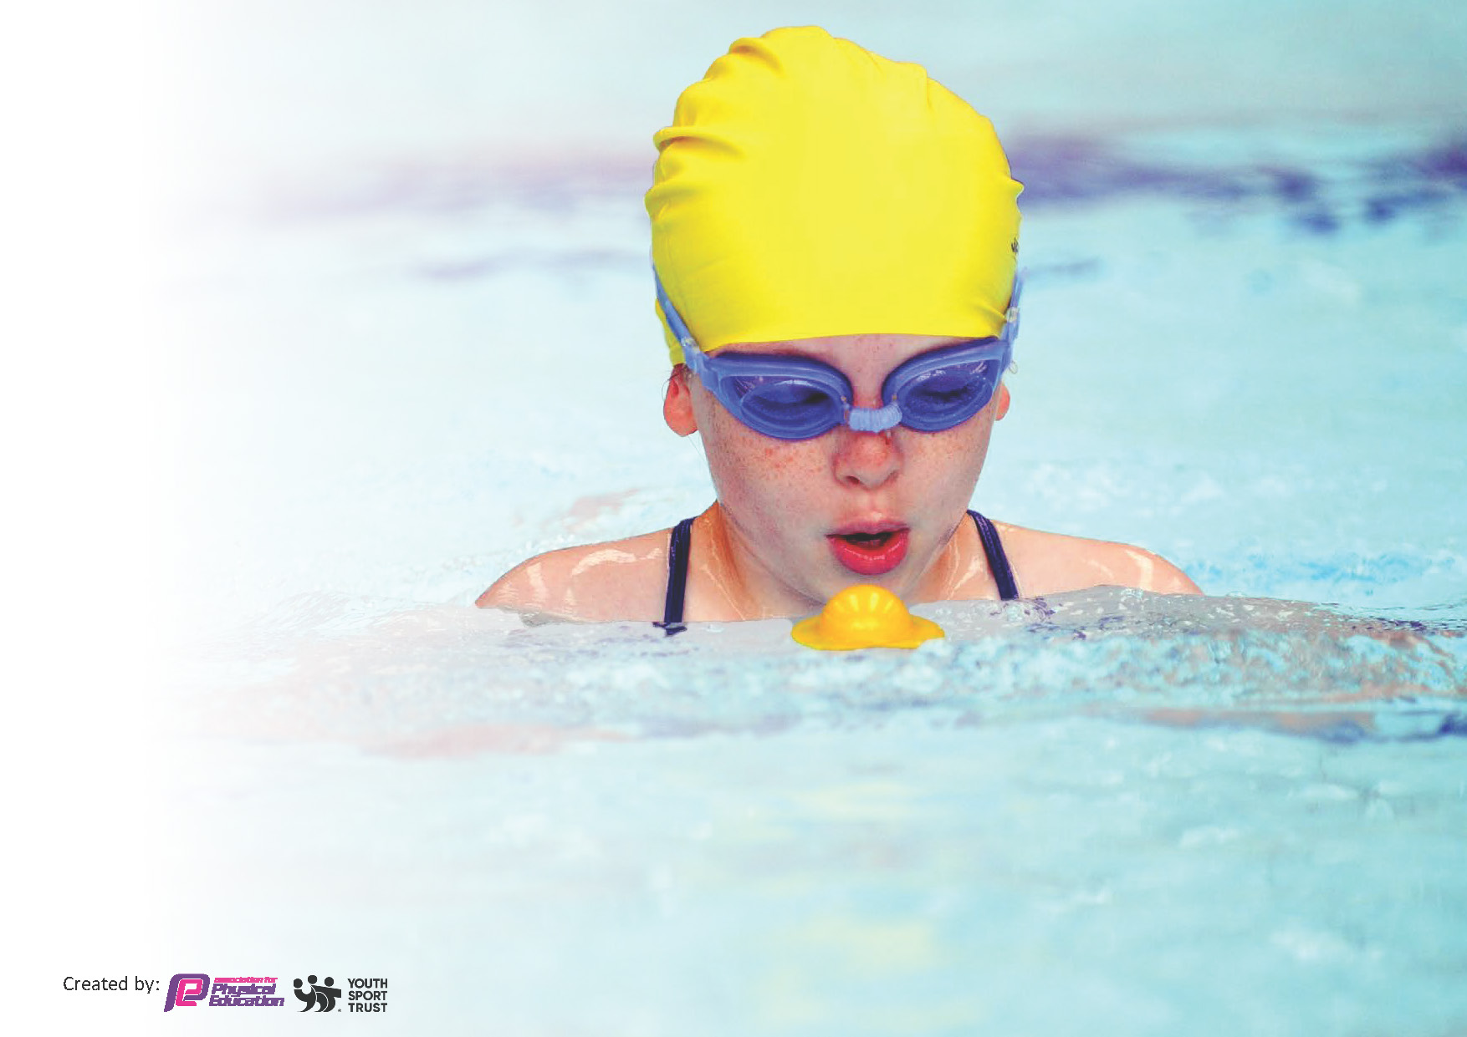
This template can be used for multiple purposes:
by:
- It enables schools to effectively plan their use of the Primary PE and sport premium
- It helps schools to meet the requirements (as set out in guidance) to publish information on their Primary PE and sport premium
- It will be an effective document to support Ofsted inspections enabling schools to evidence progress in Physical Education (PE) and evidence swimming attainment, which forms part of the PE National Curriculum. We would recommend schools consider
the Intent, Implementation and Impact of any spend, as examined within the Education Inspection Framework.

It is important that your grant is used effectively and based on school need.

Schools must use the funding to make additional and sustainable
improvements to the quality of the PE, School Sport and Physical Activity (PESSPA)
they offer. This means that you should use the Primary PE and sport premium to:

- Build capacity and capability within the school to ensure that improvements made now will benefit pupils joining the school in future years
- Develop or add to the PESSPA activities that your school already offers.

The Primary PE and sport premium should not be used to fund capital spend projects; the school’s core budget should fund these. Further detail on capital expenditure can be found in the updated Primary PE and sport premium guidance.

The Primary PE and sport premium guidance, outlines 5 key priorities that funding should be used towards. It is not

Review of last year’s spend and key achievements (2022/2023)

We recommend you start by reflecting on the impact of current provision and reviewing your previous spend.

Activity/Action | Impact | Comments
To increase sports for all outside school.  To ensure the children make good progress across the curriculum from their starting points. | After School support and activities provided through Morecambe FC, Ludus Dance, Go Velo, Lancaster Tennis Club, Activ8, etc.  This has meant that more children have access to a range of sports outside school including:  Tennis  Dance  Gymstars  Football  Athletics  Cricket  Jujitsu  Multi-skills  Tag Rugby  PE passport in place and all staff training. Long term overview has been adapted to ensure that key strands of PE are taught in phases. This has insured that the children can compete with each other and can be selected for competition as well as supporting each other to achieve.  All staff have been trained.
Action – what are you planning to do | Who does this action impact? | Key indicator to meet | Impacts and how sustainability will be achieved? | Cost linked to the action
* Increase the hours of physical activity and range of children’s sport experiences.  Introduce play leaders and sport’s equipment during lunchtimes and break to increase active play.  Increase number of break times and active sessions during lessons.  Continue to develop the range of extra-curricular offers for the children through after school clubs and competitions. Pupil interviews to determine range of clubs.  Living Streets Walk to School Scheme to promote activity outside of school hours and promotes a parent-child focused approach. | Lunchtime supervisors / teaching staff  Pupils | Key indicator 2 -The engagement of all pupils in regular physical activity – the Chief Medical Officer guidelines recommend that all children and young people aged 5 to 18 engage in at least 60 minutes of physical activity per day, of which 30 minutes should be in school.  Key indicator 4: Broader experience of a range of sports and activities offered to all pupils. | We are working towards all children meeting their daily Active 60 minutes goal.  Sustainability- our active learning breaks during lessons and active play times are part of our school ethos. The children develop ideas for new equipment/games.  Training will be given to any new staff to ensure sustainability  Increased active learning through timetabled breaks. | Cost of play equipment and training- £5000

* To provide adaptive teaching for AGT and SEND needs throughout the curriculum.  To ensure staff confidence in the implementation of the PE curriculum through CPD.  Specialist teacher to provide support through differentiation to develop AGT during lessons and to run BEAM interventions for children with poor gross motor skills.  PE app to provide teachers with high quality sequences of learning to adapt to the needs of the children. | Primary teachers  Pupils | Key Indicator 1: Increased confidence, knowledge, and skills of all staff in teaching PE and sport. | Primary teachers will be more confident to deliver effective PE supporting pupils to undertake extra activities inside and outside of school, including teaching water safety and swimming.  Specialist teacher to provide BEAM interventions to close the gap for our SEND children and children with poor gross motor skills.  PE lead to carry out staff surveys and observe lessons to ensure their specific needs are supported. | £5000 for 5 teachers to undertake CPD.  Wages of specialist teacher to support:28,822  SSN bronze package for CPD of teachers.
* Increase the amount of children competing in sport and the range of sports.  Children to attend a variety of competitive and inclusive sporting events such as girls/boys football, glow dodgeball, multi skills, rounders, korfball, athletics.  School to host an inter-schools rounders tournament as part of LSSN membership in summer term.  Schools’ Football Week intra-house competitions during PE.  Year 3/4 intra-house Dodgeball competitions as part of LHSSN membership.  Walk to School intra-class competition. | Pupils  Parents  Teachers | Key indicator 5: Increased participation in competitive sport. | More children will be competing in a range of sports. | SSN package  Cricket package  Local school’s package  Taxi/ coach charges  LSSA competition package

Key achievements 2023-2024
This template will be completed at the end of the academic year and will showcase the key achievements schools have made with their Primary PE and sport premium spending.

Activity/Action | Impact | Comments
* Increase the hours of physical activity and range of children’s sport experiences.  * To provide adaptive teaching for AGT and SEND needs throughout the curriculum.  * Increase the amount of children competing in sport and the range of sports. | Physical activity increased through: -  * an extra afternoon break  * purchase of new playground equipment boxes available to increase levels of activity at play times  * play leaders to run activities at lunchtimes  * Living Streets Travel Tracker to promote more children to walk to school  * Additional after school clubs and competitions (korfball, dodgeball, girls/boys and mixed football, tag rugby, basketball, hockey, dance, athletics, multi skills cricket, jujitsu) enhanced and chosen through pupil interviews and our OSF pupil survey.  * additional movement breaks and active lessons are now embedded throughout school and this has vastly increased physical activity and focus  * CPD for all teachers in each year group to uplevel skills in Dance and Gymnastics, Active Learning, Disney Shooting Stars Football, Multi Skills and Cricket.  * Our new sports coordinator has provided extra support for both our AGT and SEND children, where needed through our PE lessons.  * A new sensory circuits area has been developed to support children with SEND barriers  * BEAM programme delivered to Reception by our sports coordinator to improve gross motor skills and coordination  * Funding used to upskill our sports coordinator (Healthy Movers, PE Conference, Dance and Gymnastics)  * Teachers using the Lancs PE app to support their judgements when assessing children during PE  * Our SEND children attended an inclusive football event at Morecambe Road School, which they thoroughly enjoyed.  * Wheelchair Basketball with Shaun Gash  * We have been able to send more children to competitions due to our sports coordinator.  * Our LHSSN package and LSSA package have provided children extra opportunities to attend both competitive and inclusive events, such as Glow Dodgeball, Korfball, Girls/Boys/Mixed Football, Cricket, Athletics League, Colour Dash 5K etc  *Children have been exposed to intra competitions such as rounders, wheelchair basketball, dodgeball, athletics and football.

Swimming Data
Meeting National Curriculum requirements for swimming and water safety.
Priority should always be given to ensuring that pupils can perform safe self-rescue even if they do not fully meet the first two requirements of the National Curriculum programme of study

Question | Stats: | Further context  Relative to local challenges
What percentage of your current Year 6 cohort can swim competently, confidently and proficiently over a distance of at least 25 metres? | 81% | 21/26 of our Y6 cohort can now use a range of strokes effectively, over 25 metres. This is due to an intense catch-up programme of swimming twice a week for a whole term.
What percentage of your current Year 6 cohort can use a range of strokes effectively [for example, front crawl, backstroke, and breaststroke]? | 81% | 21/26 of our Y6 cohort can now use a range of strokes effectively. This is due to an intense catch-up programme of swimming twice a week for a whole term.

What percentage of your current Year 6 cohort are able to perform safe self-rescue in different water-based situations? | 81% | Due to our catch-up swimming programme, 21/26 of our Y6 cohort are able to perform safe self-rescue in different water-based situations.
If your schools swimming data is below national expectation, you can choose to use the Primary PE and sport premium to provide additional top-up sessions for those pupils that did not meet National Curriculum  requirements after the completion of core lessons. Have you done this? | Yes/No | At the beginning of the year, only 3 out of the 26 Year 6 cohort could swim. We have used the funding to provide the Year 6 cohort with one term of catch-up swimming at Carnforth Swimming Pool.
Have you provided CPD to improve the knowledge and confidence of staff to be able to teach swimming and water safety? | Yes/No | Louise Hulse

Signed off by:

Head Teacher: | Lucy Naylor
Subject Leader or the individual responsible for the Primary PE and sport premium: | Laura Hillyer
Governor: | Nick Harrison  Chair of Governors
Date: | October 2023

